Cental Calcutta Polytechnic


21, Convent Rd, Philips, Sealdah, Kolkata, West Bengal 700014

Department: Computer Science and Technology

Name: Suman Mondal
Roll: DCCPCSTS3
No: 10005537
Subject: Programming in C
Year: 2nd

2020-21
INDEX
Serial Number | Program Name | Page No. | TeacherSign.
Assignment-1
1 | C program to perform input/output of all basic data types | 4
2 | C program to enter two numbers and find their sum | 5
3 | C program to enter two numbers and perform all arithmetic operations | 6
4 | C program to enter length and breadth of a rectangle and find its perimeter | 7
5 | C program to enter length and breadth of a rectangle and find its area | 8
6 | C program to enter radius of a circle and find its diameter, circumference and area | 9
7 | C program to enter length in centimeter and convert it into meter and kilometer | 10
8 | C program to enter temperature in celsius and convert it into Fahrenheit | 11
9 | C Program to enter temperature in fahrenheit and convert to celsius | 12
10 | C program to convert days into years, weeks and days | 13
11 | C program to find power of any number x^y | 14
12 | C program to enter any number and calculate its square root | 15
13 | C program to enter two angles of a triangle and find the third angle | 16
14 | C program to enter base and height of a triangle and find its area | 17
15 | C program to calculate area of an equilateral triangle | 18
16 | C program to enter marks of five subjects and calculate total,average and percentage | 19
17 | C program to enter P,T,R and calculate simple interest | 20
18 | C program to enter P,T,R,n and calculate compound interest | 21

Assignment-1
Q01.Write a C program to perform input/output of all basic data types.

Program Code:

#include<stdio.h>
main(){
int x;
float y;
char z;
printf("Enter any integer no.:: ");
scanf("%d",&x);
printf("Enter any fractional no.:: ");
scanf("%f",&y);
printf("Enter any character:: ");
scanf(" %c",&z); //Space for clearing buffer
printf("\n***You Entered***\n");
printf("Interger: %d\nFloat: %0.2f\nCharacter:%c\n",x,y,z);

}
Program Output:
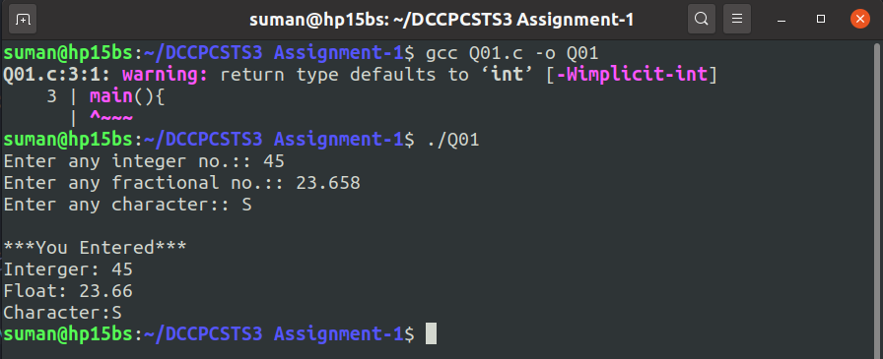
Q02.Write a C program to enter two numbers and find their sum.

Program Code:

#include<stdio.h>
main(){
int x,y,sum;
printf("Enter 1st number:: ");
scanf("%d",&x);
printf("Enter 2nd number:: ");
scanf("%d",&y);
sum=x+y;
printf("Sum of %d and %d is %d\n",x,y,sum);
}

Program Output:

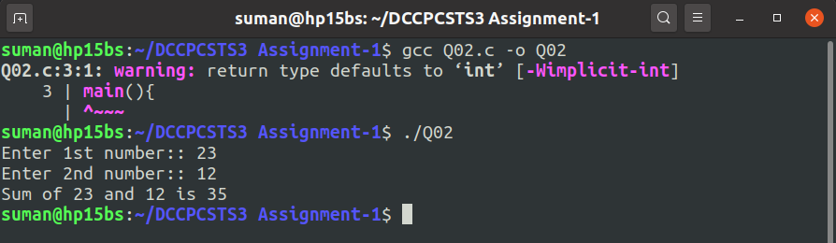

Q03.Write a C program to enter two numbers and perform all arithmetic operations.

Program Code:

#include<stdio.h>
main(){
int x,y;
int sum,sub,mul,div;
printf("Enter 1st number:: ");
scanf("%d",&x);
printf("Enter 2nd number:: ");
scanf("%d",&y);
sum = x+y;
sub = x-y;
mul = x*y;
div = x/y;
printf("\n*Arithmetic Operations of %d and %d are:",x,y);
printf("\nAddition: %d\nSubtraction: %d\nMultiplication: %d\nDivision: %d\n",sum,sub,mul,div);
}
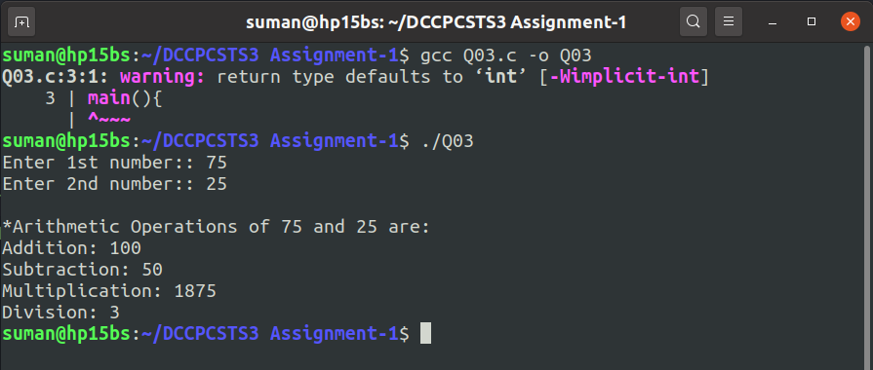
Program Output:
Q04.Write a C program to enter length and breadth of a rectangle and find its perimeter.

Program Code:

#include<stdio.h>
main(){
int lngt,brdt,peri;
printf("Enter the length: ");
scanf("%d",&lngt);
printf("Enter the breadth: ");
scanf("%d",&brdt);
peri = 2*(lngt+brdt);
printf("Perimeter of the rectangle is %d unit\n",peri);
}

Program Output:

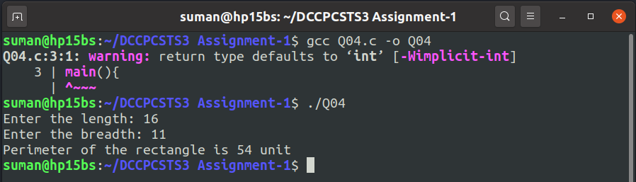

Q05.Write a C program to enter length and breadth of a rectangle and find its area.

Program Code:

#include<stdio.h>
main(){
int lngt,brdt,area;
printf("Enter the length: ");
scanf("%d",&lngt);
printf("Enter the breadth: ");
scanf("%d",&brdt);
area = lngt*brdt;
printf("Area of the rectangle is %d squnit\n",area);
}

Program Output:

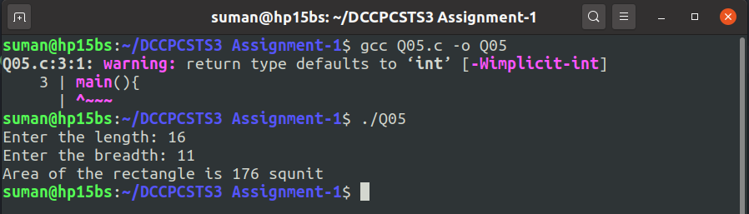

Q06.Write a C program to enter radius of a circle and find its diameter, circumference and area.

Program Code:

#include<stdio.h>
main(){
int radi,dia;
float pi=3.14,circ,area;
printf("Enter the radius of the circle: ");
scanf("%d",&radi);
dia= 2*radi;
circ= pi*dia;
area= pi*radi*radi;
printf("The Circle's--\nDiameter: %d\nCircumference: %0.2f\nArea: %0.2f\n",dia,circ,area);
}

Program Output:

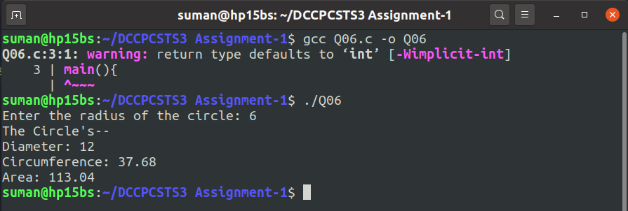

Q07.Write a C program to enter length in centimeter and convert it into meter and kilometer.

Program Code:

#include<stdio.h>
main(){
float cemi,meter,kilo;
printf("Enter length in centimeter: ");
scanf("%f",&cemi);
meter = (float)cemi/100;
kilo = (float)cemi/100000;
printf("length in meter: %.4f meter\n",meter);
printf("length in kilometer: %.4f kilometer\n",kilo);
}

Program Output:

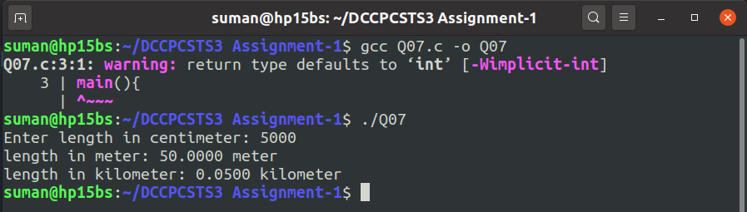

Q08.Write a C program to enter temperature in celsius and convert it into Fahrenheit.

Program Code:

#include<stdio.h>
main(){
float cel,farh;
printf("Enter temperature in celsius: ");
scanf("%f",&cel);
farh =(9*cel+160)/5;
printf("Temperature in fahrenheit: %.2f°F\n",farh);
}

Program Output:

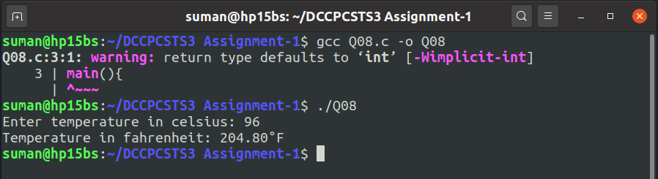

Q09.Write a C Program to enter temperature in fahrenheit and convert to celsius.

Program Code:

#include<stdio.h>
main(){
float cel,farh;
printf("Enter temperature in fahrenheit: ");
scanf("%f",&farh);
cel =(5*farh-160)/9;
printf("Temperature in celsius: %.2f°c\n",cel);
}

Program Output:

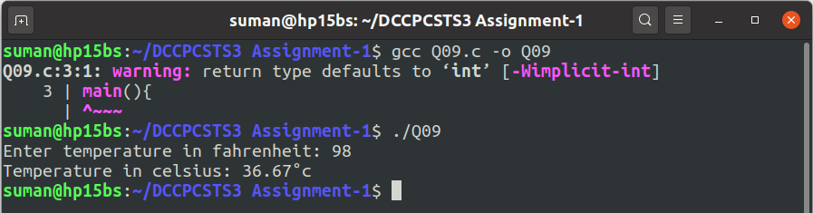

Q10.Write a C program to convert days into years, weeks and days.

Program Code:

#include<stdio.h>
main(){
int day;
int year,week;
int tem;
printf("Enter days you want to calculate: ");
scanf("%d",&day);
tem=day;
year=day/365;
day=day%365;
week=day/7;
day=day%7;
printf("**%d days means--\n",tem);
printf("Year(s): %d\nWeek(s): %d\nDay(s): %d\n",year,week,day);
}

Program Output:

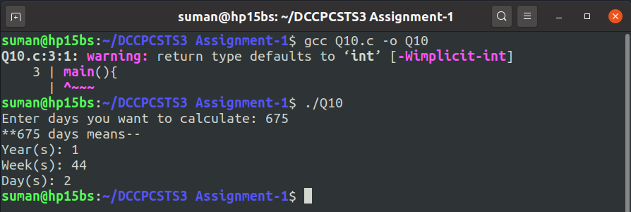

Q11.Write a C program to find power of any number x^y.

Program Code:

#include<stdio.h>
#include<math.h>
main(){
int x,y,power;
printf("Enter the base value you want to calculate: ");
scanf("%d",&x);
printf("Enter the power value you want to calculate: ");
scanf("%d",&y);
power=pow(x,y);
printf("So,%d to the power %d is %d\n",x,y,power);
}

Program Output:
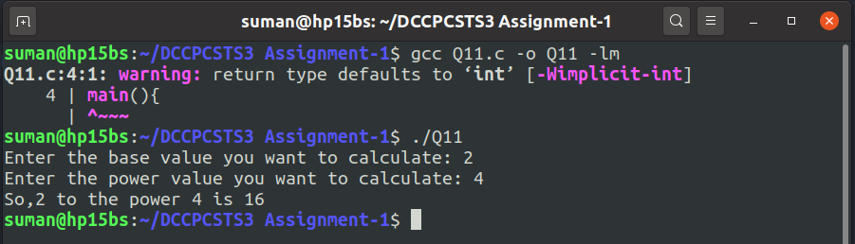

Q12.Write a C program to enter any number and calculate its square root.

Program Code:

#include<stdio.h>
#include<math.h>
main(){
int num,squrt;
printf("Enter number you want to calculate square root: ");
scanf("%d",&num);
squrt=sqrt(num);
printf("So,Square Root of %d is %d\n",num,squrt);
}

Program Output:

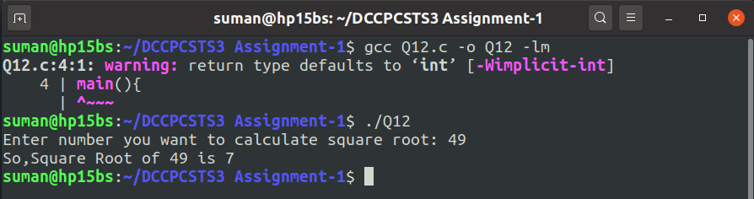

Q13.Write a C program to enter two angles of a triangle and find the third angle.

Program Code:

#include<stdio.h>
main(){
float ang1,ang2,ang3;
printf("Enter 1st angle of the triangle: ");
scanf("%f",&ang1);
printf("Enter 2nd angle of the triangle: ");
scanf("%f",&ang2);
ang3=180-(ang1+ang2);
printf("Third angle of the triangle is %.2f degree\n",ang3);
}

Program Output:

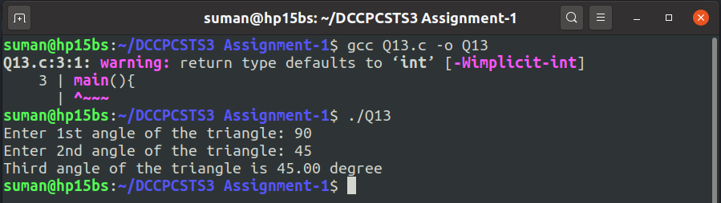

Q14.Write a C program to enter base and height of a triangle and find its area.

Program Code:

#include<stdio.h>
main(){
int base,hgt,area;
printf("Enter the base of the triangle: ");
scanf("%d",&base);
printf("Enter the height of the triangle: ");
scanf("%d",&hgt);
area=(base*hgt)/2;
printf("Area of the triangle is: %d\n",area);
}

Program Output:

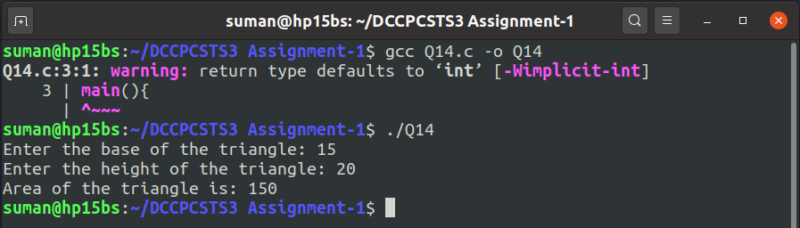

Q15.Write a C program to calculate area of an equilateral triangle.

Program Code:

#include<stdio.h>
main(){
int side;
float area;
printf("Enter the side of the triangle: ");
scanf("%d",&side);
area=0.433*(side*side);//squr root(3)/4=0.433
printf("Area is %.2f\n",area);
}

Program Output:

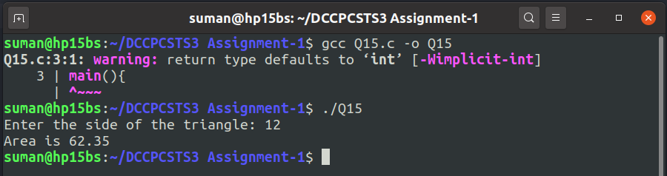

Q16.Write a C program to enter marks of five subjects and calculate total,average and percentage.
Program Code:
#include<stdio.h>
main(){
int ben,eng,math,phy,coms;
int total;
float avg,prcn;
printf("Enter marks of Bengali: ");
scanf("%d",&ben);
printf("Enter marks of English: ");
scanf("%d",&eng);
printf("Enter marks of Math: ");
scanf("%d",&math);
printf("Enter marks of Physics: ");
scanf("%d",&phy);
printf("Enter marks of Computer Science: ");
scanf("%d",&coms);
total=ben+eng+math+phy+coms;
avg=total/5;
prcn=total*0.2;
printf("--------------------------------\n");
printf("Total: %d\nAverage: %.2f\nPercentage: %.2f\n",total,avg,prcn);
}
Program Output:
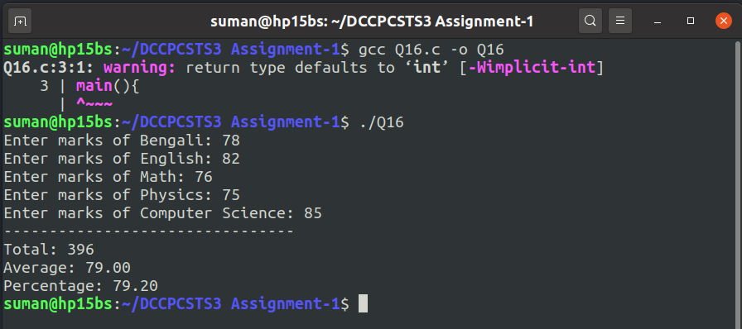
Q17.Write a C program to enter P,T,R and calculate simple interest.

Program Code:

#include<stdio.h>
main(){
int prin,time;
float rate,si;
printf("Enter your Principal Balance: ");
scanf("%d",&prin);
printf("Enter time in year: ");
scanf("%d",&time);
printf("Enter Rate of Interest: ");
scanf("%f",&rate);
si=(prin*time*rate)/100.0;
printf("Simple Interest is: %.2f\n",si);
}

Program Output:

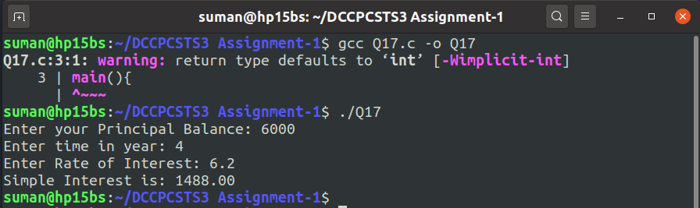

Q18.Write a C program to enter P,T,R and calculate compound interest.

Program Code:

#include<stdio.h>
#include<math.h>
main(){
int prin,time;
float rate,fa,ci;
printf("Enter your Principal Balance: ");
scanf("%d",&prin);
printf("Enter time in year: ");
scanf("%d",&time);
printf("Enter Rate of Interest: ");
scanf("%f",&rate);
fa=(float)(prin*pow((1+rate/100),time));
ci=(float)fa-prin;
printf("So,Annual Compound Interest: %.2f\nFinal Amount: %.2f\n",ci,fa);
}

Program Output:

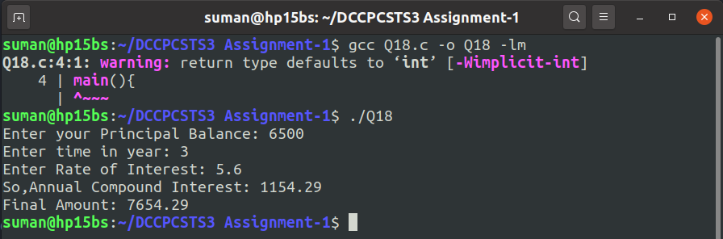

<--Made with LOVE by Suman Mondal-->

